**KARANAM YESWANTH TEJA**

**289224**

**CASE STUDY**

1. Check your current working directory



1. Before starting the migration, ensure you have the following tools installed:

Git , Subversion (SVN) , Git - svn

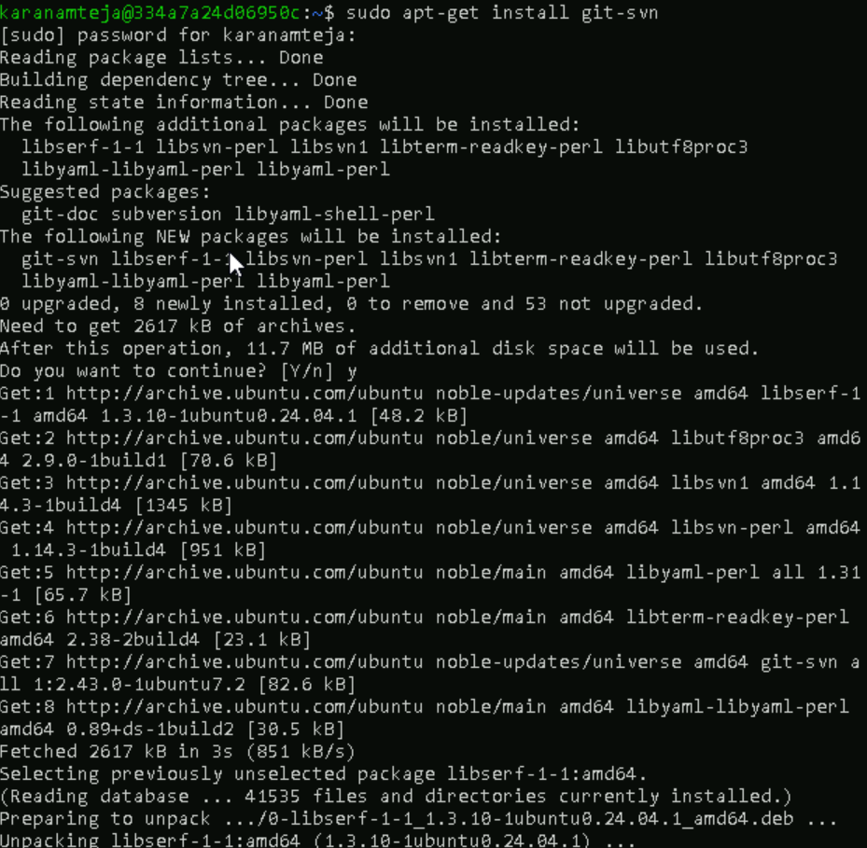

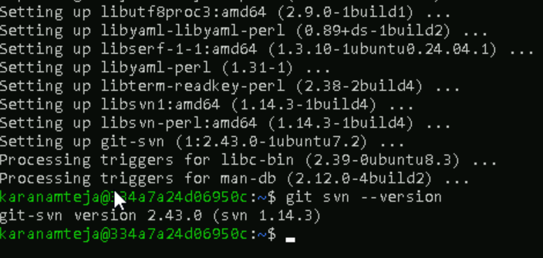

1. Create an empty directory for your new Git repository and initialize it:

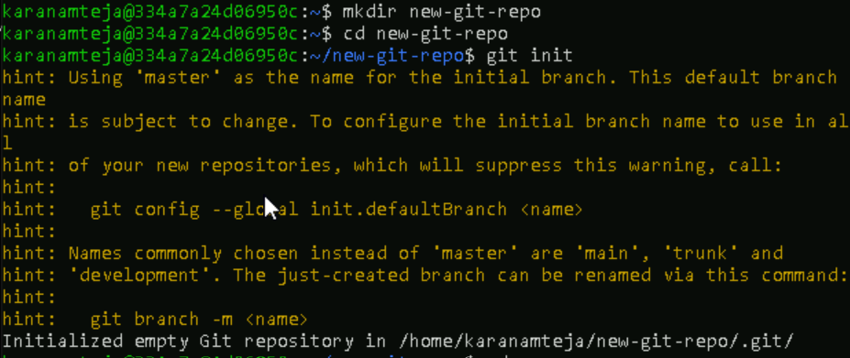

1. Install subversion(SVN) to create a SVN repository

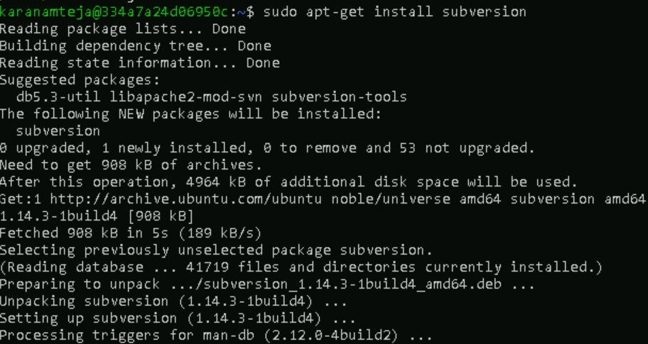

1. Create a SVN repository and repository structure



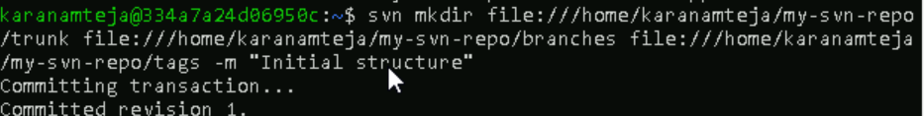



1. Create a test directory called **my-working-copy** and add files like **test-file.txt** and **file.txt.**
2. Add the new files to svn and commit the changes using **svn add and svn commit commands.**
3. **Verify the changes using svn log command**
4. **Checkout the repository to work locally**

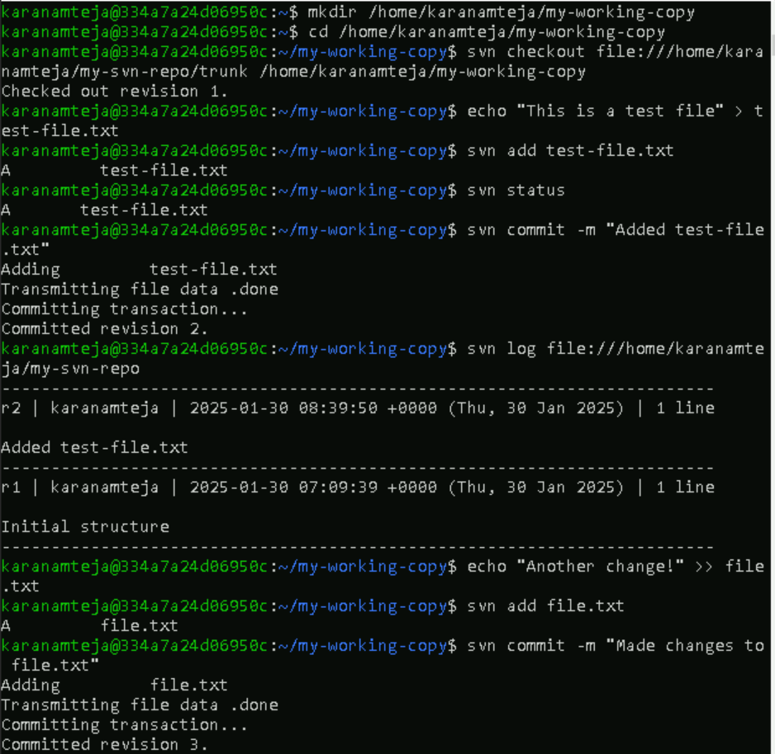

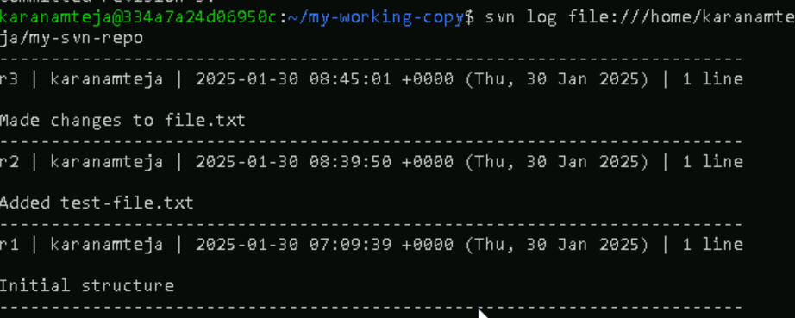

1. Import the files from test directory to your svn repository and verify the changes

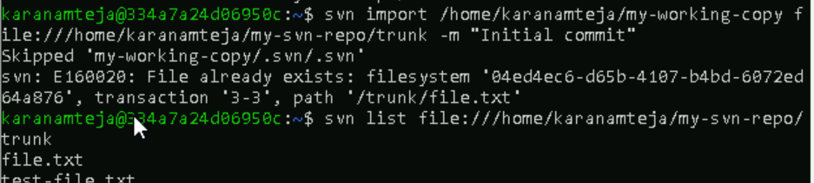

1. Now you will use svn-git to clone the SVN repository into your git repository new-git-repo

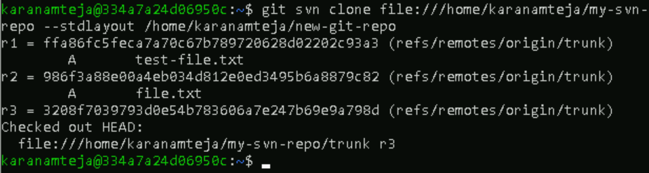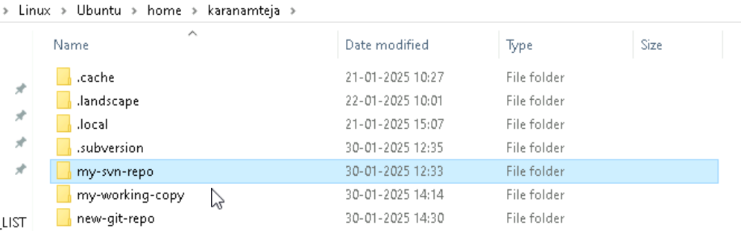

1. Check the history

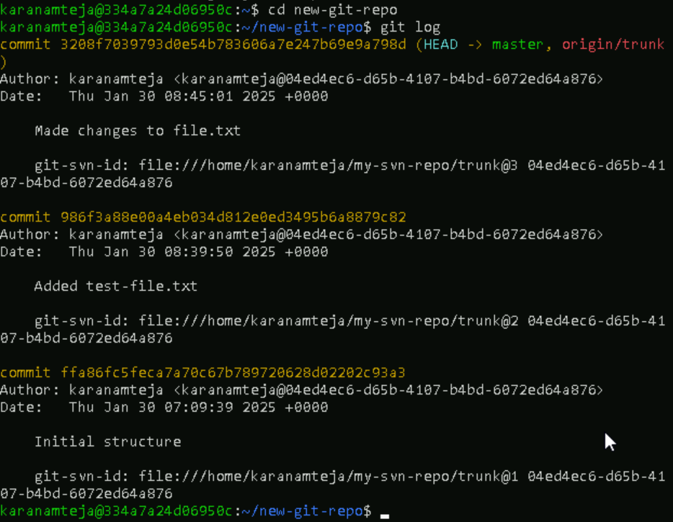

1. By default git-svn maps svn branches to git branches



1. To push our files to github, set the url of our github repository and push all our files to that repository.



